**Setting Shape Color and Inserting an Outline**

https://www.youtube.com/watch?v=ypjZnNwxiCI&index=27&list=PLRtjMdoYXLf776y4K432eL_qPw4na_py3

#include "stdafx.h"

#include "SFML/Graphics.hpp"

#include <iostream>

#include <windows.h>

int main()

{

sf::RenderWindow window (sf::VideoMode(600, 600), "SFML works!");

sf::CircleShape circle(150);

circle.setRadius(200);

circle.setPointCount(300);

// circle.setFillColor(sf::Color::Cyan);

circle.setFillColor(sf::Color(255, 155, 155, 100)); // 4th arg is transparency

circle.setOutlineColor(sf::Color::Red);

circle.setOutlineThickness(-10); // negative goes inward, plus -ll-

while (window.isOpen()) {

sf::Event event;

while (window.pollEvent(event)) {

switch (event.type) {

case sf::Event::Closed:

window.close();

break;

}

}

window.clear();

window.draw(circle);

window.display();

}

}

**Result**

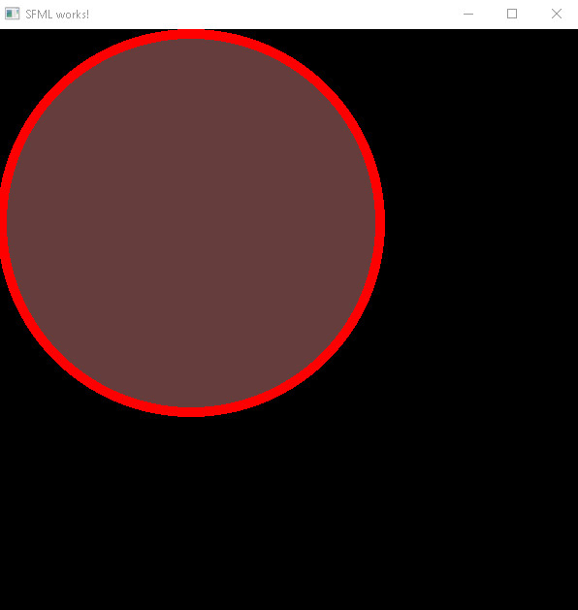

**Important points:**

* circle.setOutlineThickness(-10); this line of code sets the thickness of the outline of the specified shape. Negative arguments lets the thickness curve inwards, whereas a positive value lets the outline curve outwards – creating some extra area.